Cmake And Make

CMake is an open-source, cross-platform family of tools designed to build, test and package software. CMake is used to control the software compilation process using simple platform and compiler independent configuration files, and generate native makefiles and workspaces that can be used in the compiler environment of your choice.

Steps to build Project using Cmake and make.

1. First Create a CMakeLists.txt file in the project folder.

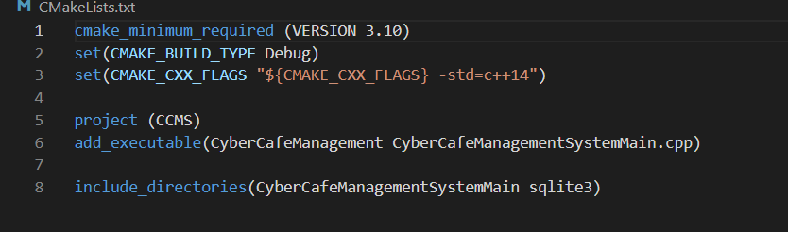

1. Then Write the above code inside the CMakeLists.txt file.

The above code is a configuration file Code which tells the Cmake tool to build the project in Debug mode or to set the executable file name etc.

1. Open the cmd terminal in the project directory and run “cmake .” Command.

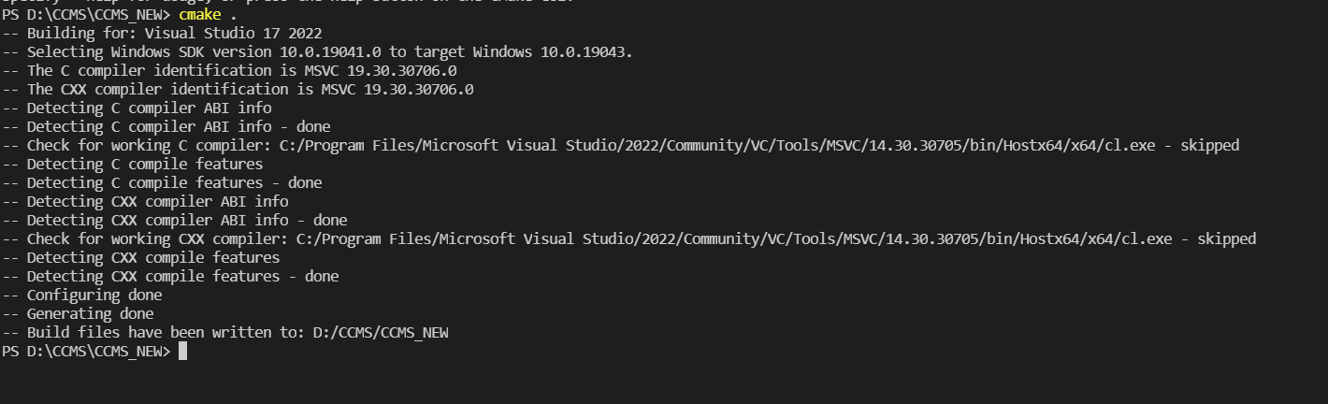

1. This will create a Makefile.

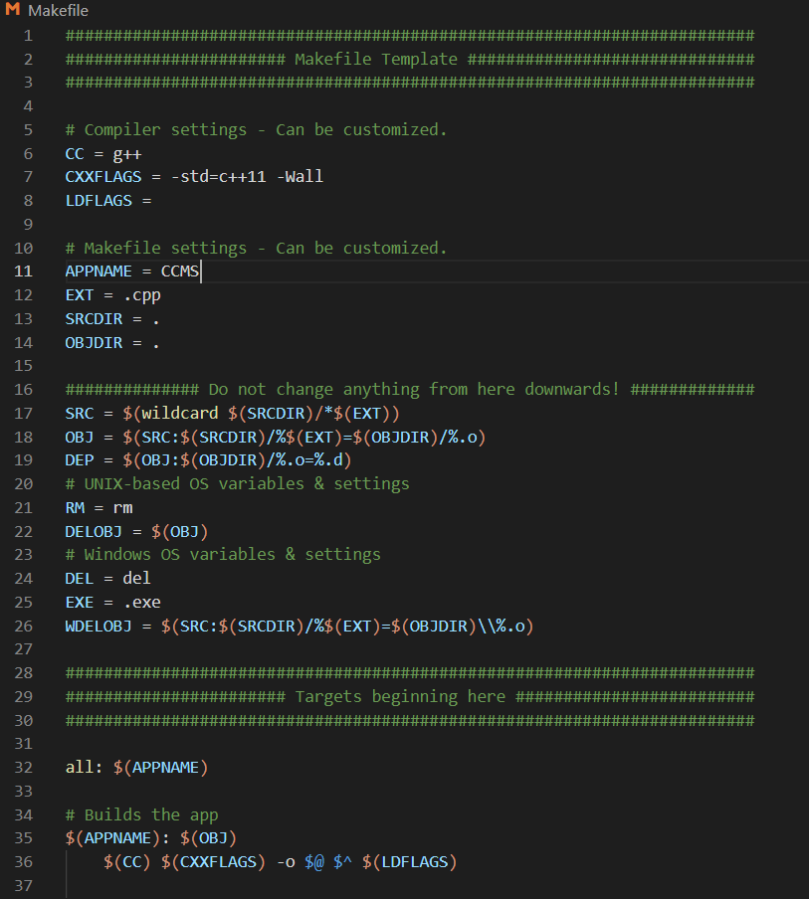

1. This MakeFile is a configuration file to tell the src directory of the project and the extension of the source files as well.
2. After Successfully creating the MakeFile type “make” command to Actually build native files of the project and .exe to Run the project.

Explicitly Creating MakeFile

(Different Approach)

In this method we make a series of files instead of just using the once make command.

1. First Step : Creating the MakeFile to Create the sqlite3.obj file.

We have the sqlite3 files in the directory.

So Write the Following Commands to make the sqlite3.obj

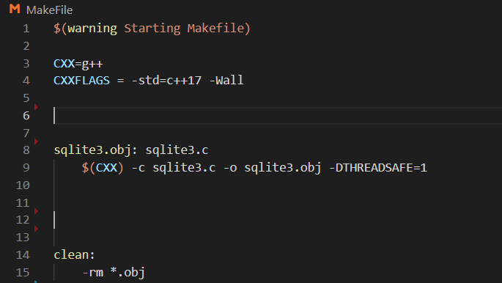

1. After writing this code in the makeFile we run “make” command.

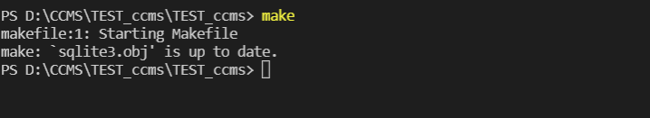

Here we successfully completed creating sqlite3.obj

1. Now We have to create object files for our .cpp files. Do the required changes to the MakeFile to create .obj files.



1. Run the make Command again.

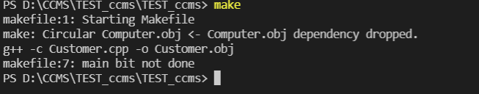

1. Ignore the error “main bit not done”. As we haven’t added any code for .exe file.

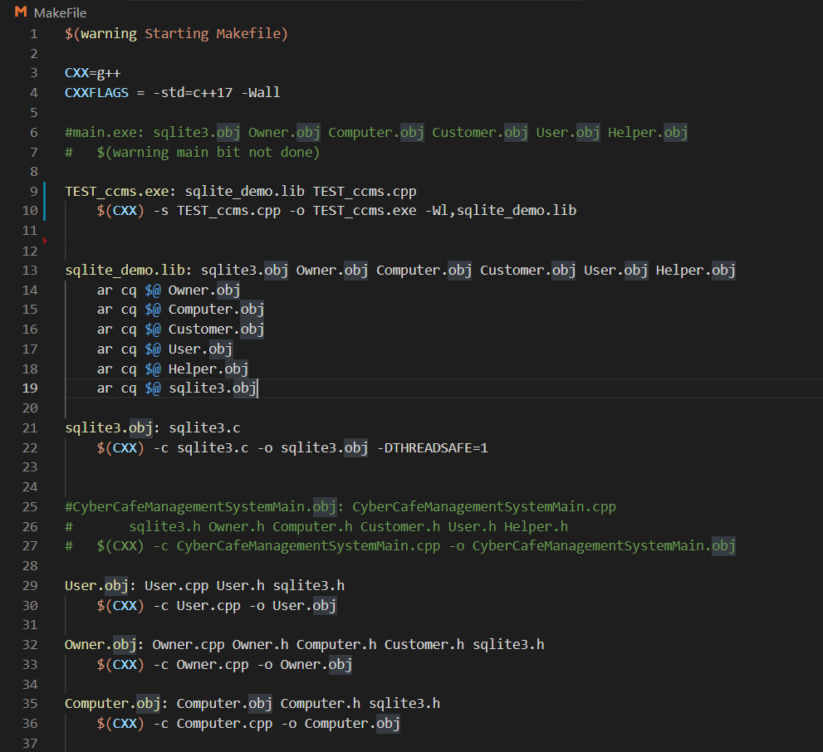

1. Add the Code For sqlite_demo_lib file only.

Use the make command again.

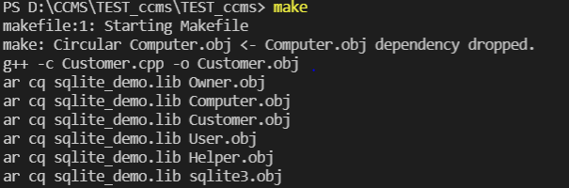

1. Add the code to create a .exe file from the main file.



1. Run make command and .exe file is being successfully created.

